Project Design Phase-I
Solution Architecture
Date | 29 September 2026
Team ID | SWTID-2026-7108
Project Name | Ai-WeatherWise API

Solution architecture is a complex process with many sub-processes that bridges the gap between business problems and technology solutions. It describes the structure, characteristics and behaviour of the application and its components.

Architecture Diagram
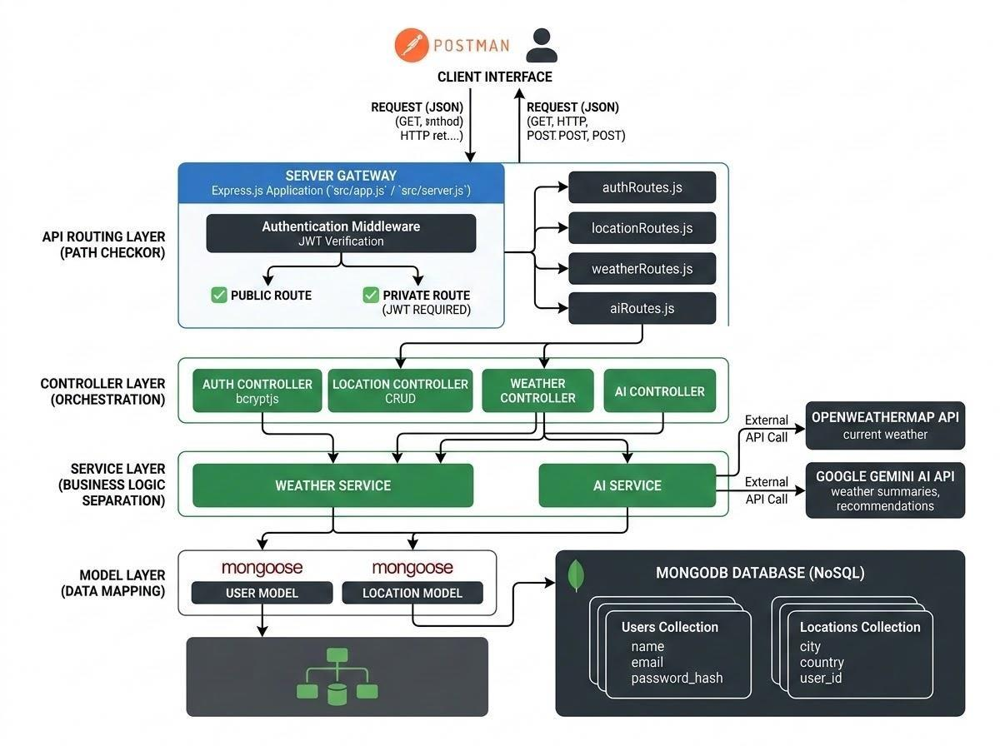
Figure 4: Solution architecture (Client, API routing, Controller, Service and Model layers)

Components Definition
- Interface: API tools like Postman send requests to distinct route paths and receive JSON responses.
- Express Server Gateway: listens on the network port, maps HTTP methods (GET, POST, PUT, DELETE), parses JSON payloads and handles CORS headers.
- Authentication Middleware: extracts the token from request headers, validates the JWT signature and allows or blocks access to private routes.
- Controllers and Services: the controller layer orchestrates each request; the service layer holds weather and AI business logic and calls OpenWeatherMap and Google Gemini.
- Database Interface Layer: Mongoose translates application logic into MongoDB queries for the User and Location collections.
- AI Service Integration: uses the Google Gemini SDK to produce weather summaries and personalised recommendations from live temperature and conditions.

MVC Architecture Pattern
The system follows the Model-View-Controller pattern to decouple its components.
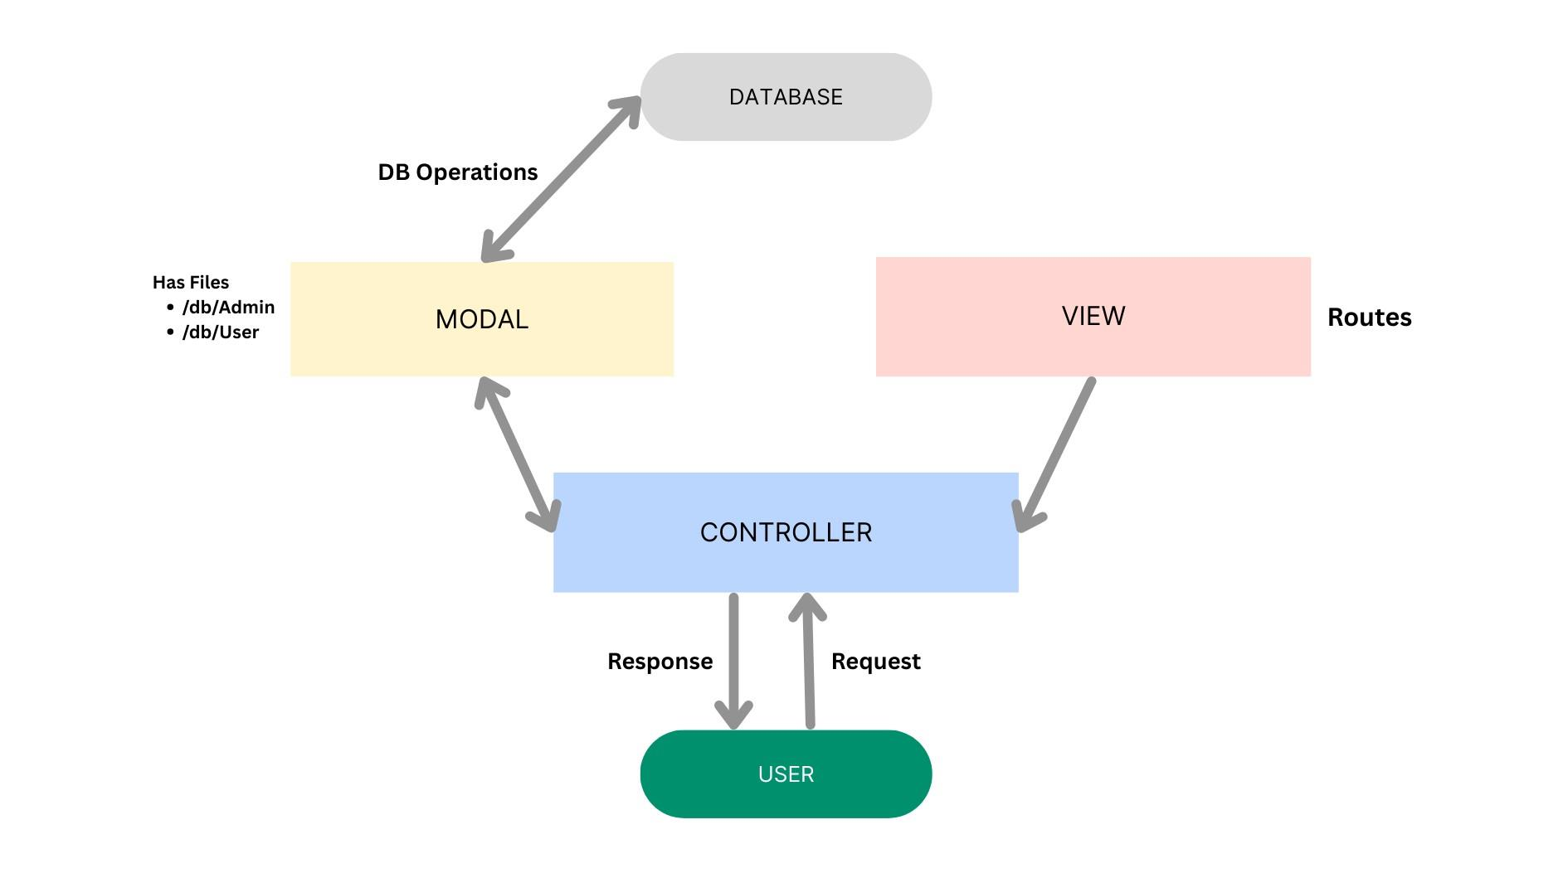
Figure 5: MVC architecture
- Model layer: Mongoose schemas define fields, defaults, indexes and validation before data is stored.
- Controller layer: captures requests from routes, checks constraints, delegates work to models and services and returns standard JSON.
- View layer: this is a headless backend, so the interface is the API routing layer that links request paths to controller handlers.

Entity-Relationship Diagram
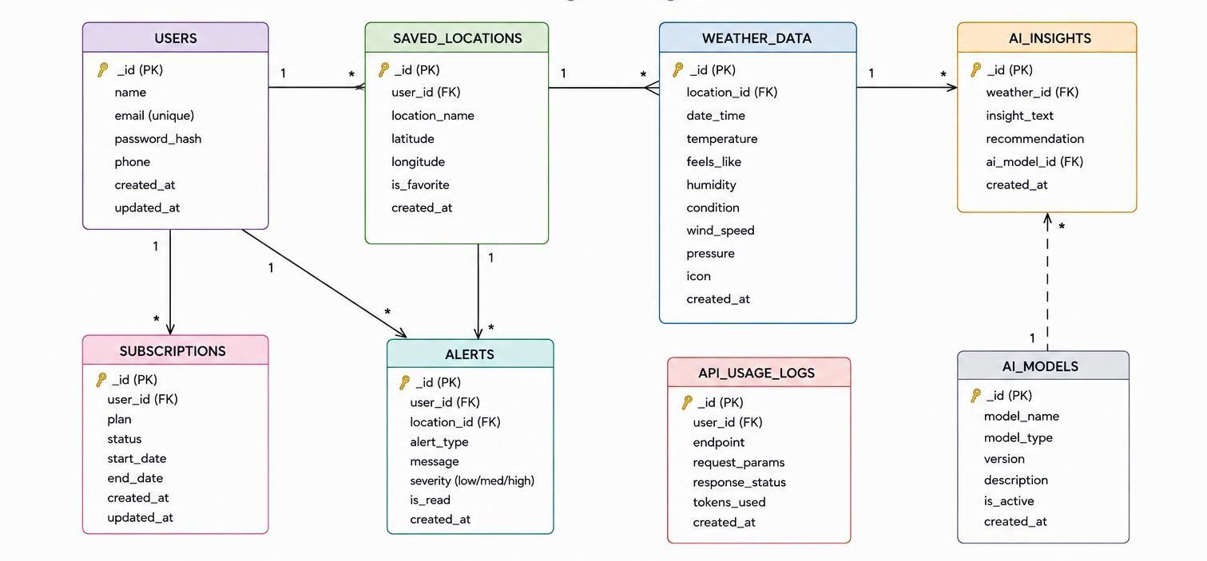
Figure 6: Entity-relationship diagram
User entity: _id (ObjectId, primary key), name (String, required), email (String, required, unique), password (String, hashed, required), createdAt and updatedAt (timestamps).
Location entity: _id (ObjectId, primary key), user (reference to User, required), city (String, required), country (String, required), createdAt and updatedAt (timestamps). A unique index on user, city and country prevents duplicate favourites.
Relationship: one User has many Locations (one-to-many).

User Flow
- User logs in or registers.
- User saves a favourite city via the API.
- User fetches current weather metrics for that city.
- User requests AI-driven insights (summary or recommendation) based on the weather data.
- System validates the JWT and returns the requested information.
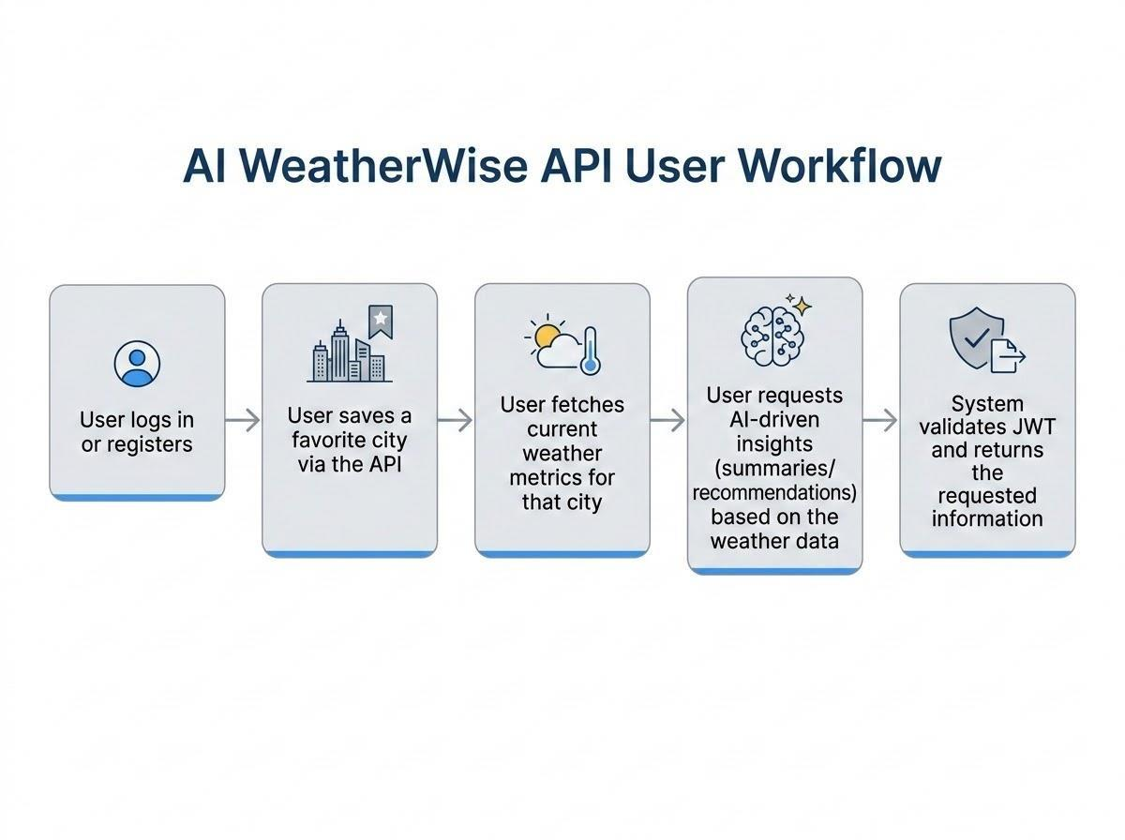
Figure 7: AI WeatherWise API user workflow

Key Features
- Role-aware route guarding: token processing blocks unauthorised requests from private endpoints.
- Favourite location management: full create, read and delete of saved cities per user.
- Weather and AI insights: live metrics with Gemini-generated summaries and recommendations.
- Fallback mode: mock weather and recommendations keep the API working without external keys.
- Sanitisation safeguards: payload sanitisation reduces XSS and NoSQL injection risk.

Roles and Responsibilities
- Admin: manages user accounts, oversees API health and system logs, and monitors database integrity.
- Registered user: maintains favourite locations, requests weather data, uses Gemini insights and manages their own credentials.

